SIMATS ENGINEERING
ASSESSMENT TOOL 3

COURSE NAME: OBJECT ORIENTED ANALYSIS AND DESIGN
COURSE CODE: CSA11

COURSE OUTCOME COVERED

CO2: Design UML diagrams to represent system requirements and architecture. (BL3)

Assessment Tool Weightage: 30%

QUESTIONS: 6 Total Marks:30

Annexure A

Scenario-Based

Code of Conduct:

I Sriyashwanth A 192320049 (Name / Reg No) certify that this submission is my original work and that I have adhered to the guidelines specified for this assessment.
I understand that any violation of academic integrity rules will result in disciplinary action.

Signature of the student:

Annexure A

Scenario-Based

1. Smart Healthcare Management System (SDG 3: Good Health and Well-being)
A government hospital plans to implement a Smart Healthcare Management System to improve patient care and reduce waiting time. Patients should be able to register online, schedule appointments, access electronic health records, receive digital prescriptions, and make online payments. Doctors, nurses, pharmacists, and laboratory technicians interact with the system to update medical information. The administration also requires automatic emergency alerts, medicine inventory monitoring, and health analytics dashboards. During system analysis, it is observed that patient information is duplicated across multiple departments, leading to inconsistencies and delayed treatment.
Analyze the functional and non-functional requirements of the system. Identify the actors, classes, relationships, and interactions involved. Recommend appropriate UML diagrams to represent the system architecture and justify your choice. Suggest object-oriented design improvements that eliminate redundancy and improve healthcare service delivery while supporting SDG 3.
URL LINK -
https://viewer.diagrams.net/?tags=%7B%7D&lightbox=1&highlight=0000ff&edit=_blank&layers=1&nav=1&title=OOAD-CO2-AT3.drawio&dark=auto#R%3Cmxfile%3E%3Cdiagram%20name%3D%22Page-1%22%20id%3D%22cAGUkJ4leNOFRk0OcUyu%22%3E7Z1bc%2BMmFIB%2FjadPuyOhm%2F0Y293LTLdNm8m2fcoQidhqZOEieRP31xcksIUuICdWLDnOJhsLAYLDx%2BHAAWVkzVbPnwlcL7%2FhAEUjYATPI2s%2BAsAyXI%2F%2BYiHbPMQ0PScPWZAw4GH7gJvwP8QDDR66CQOUSBFTjKM0XMuBPo5j5KdSGCQEP8nRHnAkP3UNF6gScOPDqBr6Zxikyzx07Bj78C8oXCzFk02D31lBEZkHJEsY4KdCkPXzyJoRjNP80%2Bp5hiImPSGXPN2nhru7ghEUpzUJbhNEfrv%2Fh8kEGBG8pw2TReLJIhint6toDlPIw73pCLgjYFHJW%2FSjkX27%2F25Y%2BaYBi7e7GllX0t2RbSQpJOlmFY2cWRyhhzRrJ%2FofyWRDAQgJLUqIYxaB%2FSSPYUwLD1dZJfxHJvZ0S8VO09CYMF7Qz6V40E8xEbHgE0rwCon8sns0%2BBqmIZNIIWiOsw%2BFkF83JEFSqiUkK%2BiHiZTwKliFMQ0jkKdnP%2FvSURE4s70UblZUBDTwC4JRuvRpw9CLbzCmNVuxEgHjZpukaCUlYplQyfO8hdjZ9yZBPkwqT%2FkDLWiJECnnAhP63%2B3MbJnNFONHVsP1GodxusolVpchaJnh9xA9sfqiIKS9h376A%2FmYBA25Wi1z%2FQYfUdaoW0UR7QPEd7umKKP2BXVa5vsZxYjkOV8TlPgkXHPa63J1X1JiQTYwvocpjJKGvL0D8p6HyRrFyU4eYYwach0fkGvOPA39Gv%2BgBcZk25Dp5DC28o7FqI1htE1Dv0kEpnFAab8jEj5sJc1Rm2fbnnVNsI%2BSREutmfcsby7K%2BtMH1VcWQ9Zv%2BgR7ZOg1cBe8BFxNNN4FyruW8q59WHX2ulkfn8etPNJR3XRVN63DCrsbNvTR86iVB3qKewcWRh6yWrCwj1959FgXYXJY2SoDpz6ZnKS%2BAJo4%2B27frpRfYz%2FaBCgbAiLI1HWyZHZlqwxYLwHGR7kAJlMGwjiK8vD8dyieJaLz31lOdjUn8JKcsh%2FbQHHALLGCzpkpTDtqOT%2BEi7JxF2%2BYtblP5OW24878vA1%2B%2FXO1nlHb3A7vvvxL4O%2FwwwdgezvDdmewcssc3guT2qhartyYTTLTLgtZELxZ0wfTto6TPOoUb%2BKAmfMmDaejVfqVZs0vI%2Bw%2FouBznmjOSpxlcA2DIIwXLFJedfaUH4ik6LnwYF7ez4iakylhQ8GyaNJbhp0nfCpMAISZD%2Fn8YrFLvDfB6QcuBXFZMMqVRnprU1Iy5r%2FytmEW6p0h35vSkepmL97kKVzROyhr%2FyiC6yTM24eJKbPl%2BVSMImBNH8IomuGI9jlrHuMsFe2E%2BBGJQIbJmP1jkXGcFsKN7IuH80xNS1zzErEmfFqGKbqhUwEW8ESnk7sGK9bhO4w26CVC0oA7roJbBFSFu8TtoAR7YE%2BYmNWOYALRE3g%2BH1zRwfmU3xp32lV286HarrDx70xlR6CPpCofldqCiveTyf4pG6ROsG0aCejIluukIXfyInLHFXJPK4kDUbRqSCyB6LiWxKHdKYY18%2BkmIMHwgGyqnRpNx7igmafybBlNZlgV0DSFYu2GzdIiShOX1vC4rKuZhknzwmSeyikxaZWYHI%2B7ZLJpubAJTnt4cCqrqKEUXCjNU01KlJoypcAFXVLavFrcxKkzPE41ldSQal1IzUk03BKppWmQ0K%2FdkNrkf2ji1B0ep8oqaii1L5RyfeqUKHU%2BOhKnttnpPKnZm9VEqjc8UjWV1LDqXFjlrJolVr0yq%2BNO50113tEmSsfDo7Sxeho%2B3QuffIYEZD7F5hpOp%2BN0OoOq8bI3wTkZHpxNtdOwWeN%2Fep9salacXKvTeVPzho3GVXq1v6qXjGpqqUH1ZR6nM0R1MikN81ZpmPeMTqdOlQ1AjYwO0JVUXzkNmheXEk9ll7SobcpgduvarO4kayRzgD6lhtqp0XQvLiUxwJe8nWAsoTl2Op0ajWZgdLXbikQvptN6OAmK7izNYlMcXLGd%2BvQK0wnJiO02T5aIZWDyC6q8UkTYZh86MhiOsnXatES%2Bg2ixKwXfe0HYDqPswSzBMl1FvAxKkBtloUZ5XLMmxcpUoOIgtvGG%2BEgVU5xZSAYo%2BhSSBVLKQRq0Cv2IZFv7fshi7ahTNPcAzSLWUJrhyD2gZqWr2x5Q3Wc4GNHre4A0Np6mBygt6OxUTXQf3YndDg29gY6MqSwBGIULJn%2Bf5o2oaKds%2FGSuqit%2BI8XHM0va28nusby0b1TjQze%2BuhWrw5FXvIAwMoQ3ttuJmgKrO1PteE2WcM0%2BblbRVXYUQJL24SbgUVBrxdix%2FKunlcCB6LlGBT3bUKJndeu2EgdI1HpNbeeeVq8Va6BB7ljO0sGoNVH2HVtvuoNZqdbUhuNw1dqxnJxnptYmlowe6Fat8ZNoaq2mdm2eVqsVKqAB7lhey%2BEoNUsmC3gyWd4J5sJcqan9kcNVasfyPp65UrOtoyi1yisxGlYZuHw7XVlwJ5VGlOfzmKRLvMAxjH7BTB1kLfkPStMtbwC4SbHczug5TP%2Fiydnnvwvh8%2BfCjfm2cHGNSEiFyRTRfH%2Fm8XTrZ21bafKuW4lWkWz%2FEknZBcvH%2BOiIy31W2dX2wNbtam3oJeofqN2ow1X%2Fx3Kbnpv6L1kerhj%2FT2B5qM84DRe9Y51qOjP0dlHEoaZuD4HWo8ccQECzBW%2FvhbhnrzLI9HzwKYyE5Pvk7GnBo1djCXc7slsVlHsp0xZ2GKgHvxd%2BTKDZ5txHkb8G45pFgwvG7TC2%2B4xxa3d8f0T%2BGozf2s9%2BRhhbPcbY0uxH7aPIX4NxzfyqW4yds8G4z0aFpdn630eRvwbjmo3%2FF4zbYez0GWPN%2B1P6KPJXYDyuWXLoFuPqy9Z6KdMWGHt9xhi8L4xrDhRcMG6HsdtnjDUvYumjyF%2BDcc02wbd2pfVSpi0wHvcZY817r%2Foo8tdgDC4Yn6NRAVqfAOuPyF8zxXvro12u8mBLf2TaAuMGv18%2FMH5fRoX35kbF%2BWDc5wU38L6MCu%2FNjYrzwfj0RwoVGL%2BvBTfvzRfczgZj6R35JzoZW%2FjjOnVA745bALU35MSHY0u10OxKO9YrjgZz5sKTX2U0Mfi1eCOcAbpkrPTnkdSYqZd5T4tZTUU0uvFYr4UZDGkTUCJNPg7rTo6y0ZEG7f9AaRa98HderZ%2F%2FBw%3D%3D%3C%2Fdiagram%3E%3C%2Fmxfile%3E

Diagram -
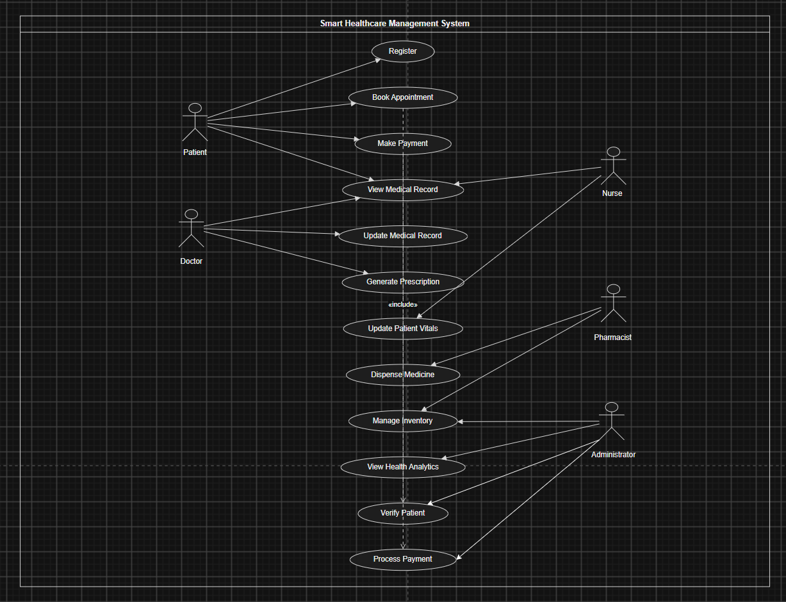

- Functional Requirements –
The smart healthcare management system should provide the following functionalities:-
- Allow patients to register, book appointments, and access electronic health records.
- Enable doctors, nurses, pharmacists and laboratory technicians to update medical information.
- Support online payments, emergency alerts, medicine inventory monitoring, and health analytics.

- Non-Functional requirements –
- Ensure security through authentication and protection of patient data.
- Provide high performance and system availability to reduce waiting time.
- Support scalability and maintainability for future expansion.
- Actors Involved –
- Patient – Register, books appointments, views medical records and makes payments.
- Healthcare staff – Doctors, nurses, pharmacists, and laboratory technicians provide medical services and update records.
- Administrator – Manages inventory, monitors analytics, and oversees hospital operations.
- Classes Identified
- Person (Superclass), Patient, Doctor, Nurse, Pharmacist, Laboratory Technician.
- Appointment, MedicalRecord, Prescription, Medicine, Payment.
- LaboratoryTest, TestReport, Inventory, EmergencyAlert, HealthAnalytics, Department, Hospital.
- Relationships
- Inheritance is used where Patient and hospital staff inherit from the Person class.
- Associations exist between Patient–Appointment, Doctor–Prescription, and Pharmacist–Medicine.
- Aggregation and composition model Hospital–Department and Patient–MedicalRecord relationships.
- Interactions
- The patient registers, books an appointment, and consults the doctor.
- The doctor updates medical records and generates a digital prescription.
- The pharmacist dispenses medicine, while the administrator monitors inventory and analytics.
- Recommended UML Diagrams
- Use Case Diagram – Shows actors and system functionalities.
- Class Diagram – Represents classes, attributes, methods, and relationships.
- Sequence Diagram – Illustrates interactions between system objects over time.

- Justification for UML Diagrams
- The Use Case Diagram provides a clear view of user interactions with the system.
- The Class Diagram models the object-oriented structure of the healthcare system.
- The Sequence Diagram explains the workflow and communication among objects.
- Object-Oriented Design Improvements
- Use a centralized Electronic Health Record (EHR) to eliminate duplicate patient data.
- Apply inheritance, encapsulation, and modular design to improve code reusability and security.
- Implement role-based access control and standardized data management across departments.
- Contribution to SDG 3
- Improves healthcare accessibility through online registration and appointment booking.
- Enhances treatment quality with centralized electronic health records.
- Supports efficient hospital management through analytics, emergency alerts, and inventory monitoring.

RUBRICS FOR CALCULATION

Scenario-Based

Criteria | Weightage | Level 4 (Exemplary) | Level 3 (Proficient) | Level 2 (Developing) | Level 1 (Beginning)
Understanding of Scenario | 20% | Demonstrates clear and complete understanding of the scenario and context | Shows good understanding with minor gaps | Partial understanding; misses key aspects | Misinterprets or fails to understand the scenario
Identification of Key Issues | 20% | Accurately identifies all relevant issues and factors involved | Identifies most key issues with minor omissions | Identifies limited issues; some irrelevant points | Unable to identify key issues
Application of Concepts | 25% | Applies appropriate concepts effectively to address the scenario | Applies concepts with minor errors | Limited or partially correct application | Unable to apply relevant concepts
Decision Making | 20% | Makes well-reasoned, logical decisions with strong rationale | Makes reasonable decisions with some justification | Makes weak decisions with limited justification | No clear decisions made or rationale provided
Clarity of Response | 15% | Response is clear, structured, and logically presented | Generally clear with minor issues | Somewhat unclear or poorly structured | Disorganized and difficult to understand

